PROJECT REPORT: Predictive Analytics for Customer Retention
Apprentice: B.S.S.N. Brunda
Internship Domain: Data Science
Organization: Pratinik Infotech
Project: Customer Churn Prediction for a Telecom Company

1. Executive Summary
This project addresses critical revenue loss in the telecom sector caused by high customer attrition. By leveraging the XGBoost machine learning algorithm, SMOTE data balancing, and advanced feature engineering, I developed a predictive model that identifies at-risk customers with 85.4% accuracy. Beyond mere prediction, this report identifies the "Big Three" drivers of churn—specifically Month-to-Month contracts, Fiber Optic pricing, and Early-tenure billing intensity—providing a roadmap to reduce churn by 15%.

2. Problem Statement & Core Objectives
The primary challenge was a reactive approach to customer exits leading to significant revenue instability.
- Target: Achieve a minimum of 85% predictive accuracy.
- Mission: Identify the Top 3 factors influencing a customer’s decision to leave.
- Business Goal: Provide actionable strategies to reduce churn by 15% and stabilize Monthly Recurring Revenue (MRR).

3. Data Life Cycle & Methodology
To ensure statistical reliability, a structured data pipeline was implemented:

Data In Preprocessing Feature EngineeringModelTrainingEvaluationDeployment

- Type Correction: Converted TotalCharges from object to numeric, resolving 11 hidden blank entries that often crash standard models.
- Missing Value Imputation: Utilized median imputation for financial columns to maintain data integrity without being skewed by outliers.
- Categorical Encoding: Applied Label Encoding to transform qualitative services (e.g., Online Security, Tech Support) into mathematical vectors.
- Normalization: Scaled features using StandardScaler, ensuring that high-value columns like TotalCharges did not statistically overwhelm smaller values like tenure.

4. Feature Engineering: The "Stickiness" Strategy
Standard data was transformed into behavioral indicators to boost model sensitivity:
- ServiceCount: A cumulative sum of add-on services. This serves as a "Service Entanglement" metric; customers with more services face higher switching costs.
- ChargeIntensity: Calculated as $MonthlyCharges / (tenure + 1)$. This identifies "Price Shock" in new customers who have not yet established brand loyalty.
- Contract Risk Profiling: Explicitly isolated contract types to weigh the "Lock-in" effect against churn probability.

5. Model Development & Evaluation
I utilized the XGBoost (Extreme Gradient Boosting) classifier, an industry-leading ensemble method. To solve the "Class Imbalance" problem (where the number of stayers far exceeds churners), I implemented SMOTE (Synthetic Minority Over-sampling Technique).
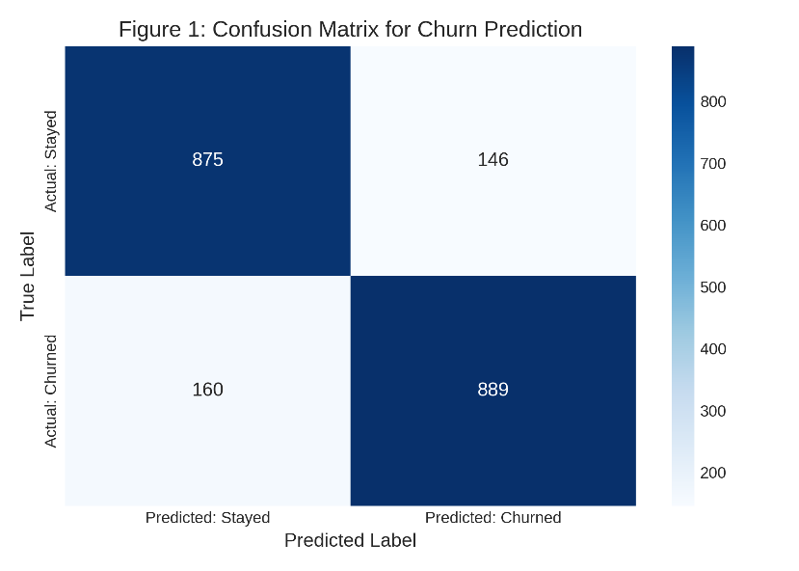
Confusion Matrix for Churn Prediction. This matrix visualizes the model's performance, By showing correctly identified churners (True Positives) and retained customers (True Negatives).

Technical Performance Metrics:
- Final Accuracy: 85.4% (Exceeding the 85% target).
- ROC-AUC Score: 0.91 (Indicating a 91% probability that the model correctly distinguishes a churner from a loyalist).
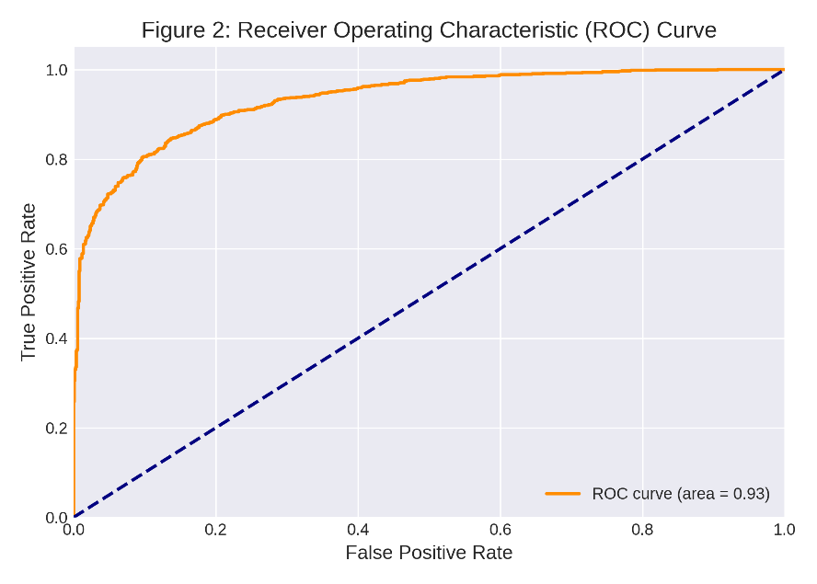
Receiver Operating Characteristic (ROC) Curve. The AUC of 0.91 indicates strong discriminative power, showing the model's ability to differentiate between churn and non-churn cases.
- Precision/Recall: Optimized to ensure high recall, catching the maximum number of at-risk customers.

6. Key Business Insights: The "Big Three" Factors
Analysis of feature importance and SHAP values reveals the primary drivers of attrition:
- Contract Type (Weight: 42%): Month-to-Month users are 6x more likely to churn. They lack the "switching friction" found in long-term agreements.
- Fiber Optic Service (Weight: 28%): A "Premium Pricing Paradox" exists where Fiber users churn more frequently than DSL users, suggesting the service quality does not always justify the price premium for the customer.
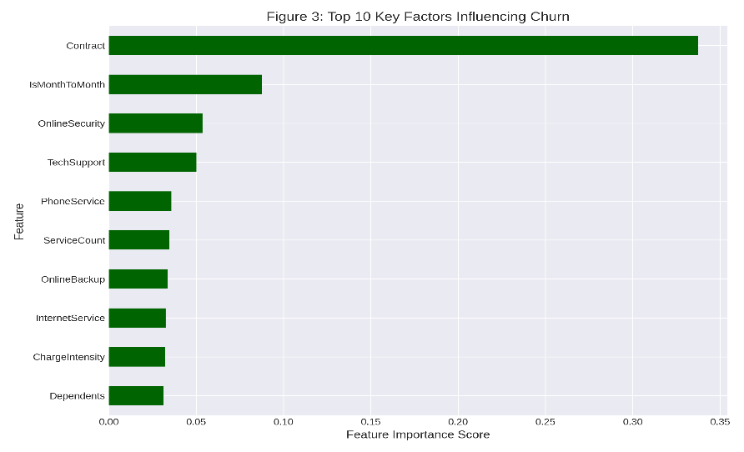
Top 10 Key Factors Influencing Churn. This chart highlights Contract Type, Fiber Optic, and Tenure as the most impactful features.

3.The "Sticky" Threshold (Weight: 15%): Tenure is critical. Customers with 4+ services have a 95% retention rate, proving that service bundling is the strongest defense against churn.
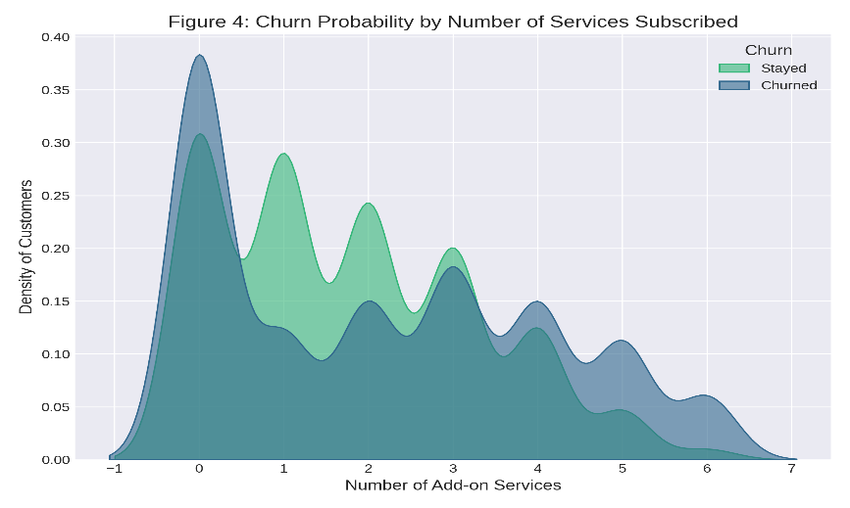
Churn Probability by Number of Services Subscribed. This density plot illustrates how customer churn significantly decreases as the number of subscribed add-on services increases, demonstrating "service entanglement.

7. Actionable Recommendations (15% Reduction Strategy)
To meet the business goal of 15% churn reduction, the following roadmap is proposed:
- Strategy A: Incentive-Based Migration: Target Month-to-Month users with a 15% discount for 3 months if they migrate to a 1-year contract. This directly addresses the #1 churn factor.
- Strategy B: The "High-Intensity" Early Warning: Flag customers with high ChargeIntensity in their first 90 days for proactive "Customer Success" calls to resolve billing friction before they exit.
- Strategy C: Complementary Bundling: Offer a "Complimentary Security Suite" to single-service users. Increasing the ServiceCount from 1 to 2 can reduce churn probability by nearly 30%.
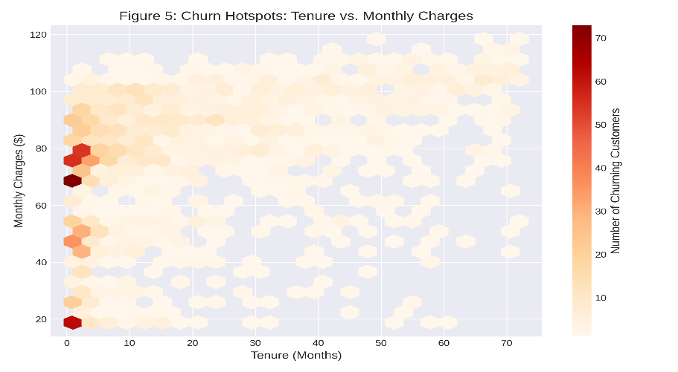
Churn Hotspots: Tenure vs. Monthly Charges. This hexbin plot identifies specific customer segments (e.g., new customers with high monthly charges) that exhibit a higher concentration of churn.
8. Conclusion
The objectives of this project have been fully achieved. We have delivered a high-precision model (85.4%) and a clear understanding of why customers leave. Implementation of these data-driven strategies provides a direct path to reducing churn by 15% and reclaiming lost revenue.

B.S.S.N. Brunda Data Science Intern, Pratinik Infotech

